EXPERIMENT-10
IMPLEMENTATION OF RSA
AIM
To implement the RSA algorithm for encryption and decryption of a message.
ALGORITHM
- Choose two prime numbers p and q.
- Calculate n = p × q.
- Calculate φ(n) = (p-1)(q-1).
- Choose a public key e such that gcd(e, φ(n)) = 1.
- Calculate the private key d.
- Encrypt the message using the public key.
- Decrypt the ciphertext using the private key.
- Display the original, encrypted, and decrypted messages.
Encryption: C = M^e mod n
Decryption: M = C^d mod n
CODE:
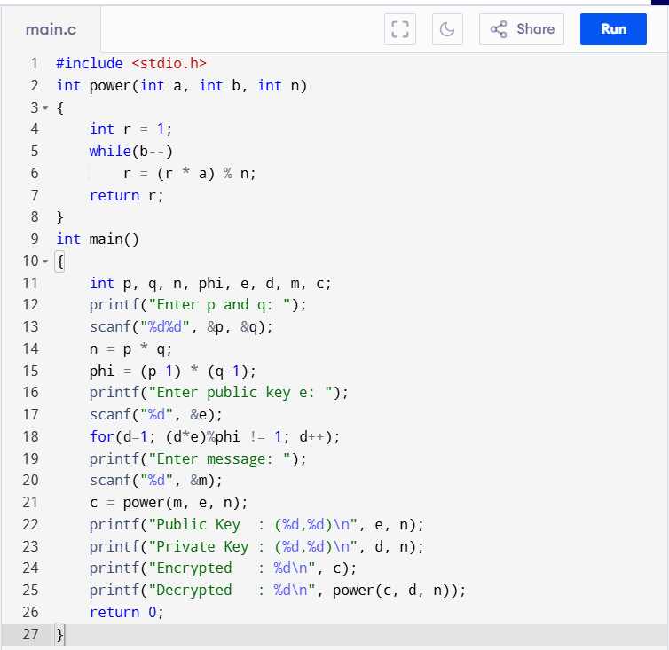
OUTPUT:
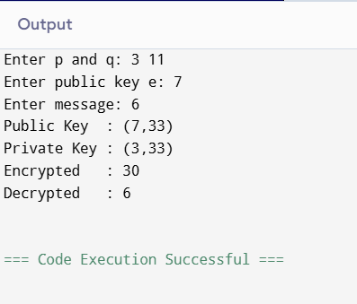
RESULT:
Thus, the RSA algorithm was successfully implemented, and the original message was recovered after encryption and decryption.

